Date: 9.19.2025



Copyright @ 2024 PibyThree.com All Rights Reserved

AI-Driven Health Chatbot implemented using RAG Model and WhatsApp Integration

Contents

1. Objective 2

2. Final Capabilities 2

3. Final n8n Workflow Architecture 3

4. AI Agent System Prompt Summary 4

a. Goals Implemented 4

b. Language Handling 4

c. Tool Usage Logic 4

d. Ethics & Safety 4

5. 3-Day Development Plan & Execution 5

6. Tech Stack 5

7. Future Scope 6

8. Summary 6

# 1. Objective

Build an AI chatbot that enables users—especially from rural/semi-urban areas—to ask health-related questions in **multiple Indian languages**, and receive accurate, general responses based on **document embeddings** via a Retrieval-Augmented Generation (RAG) pipeline.

# 2. Final Capabilities

|  |  |
| --- | --- |
| **Area** | **Description** |
| Chat Interfaces | Supports both WhatsApp and web chat |
| Multilingual Input | Input supported in English + major Indian languages |
| Language Translation | Auto-detects and translates non-English input |
| Knowledge Base | Uses scraped health documents stored in a Supabase vector DB |
| Context Memory | Remembers context via Postgres Chat Memory |
| Document Loading | Scraped, cleaned, and chunked content from [1mg.com/diseases](https://www.1mg.com/diseases) |
| Chat Model | OpenAI GPT for response generation |
| Tool Prioritization | Vector Search → Internal KnowledgeBase fallback |

# 3. Final n8n Workflow Architecture

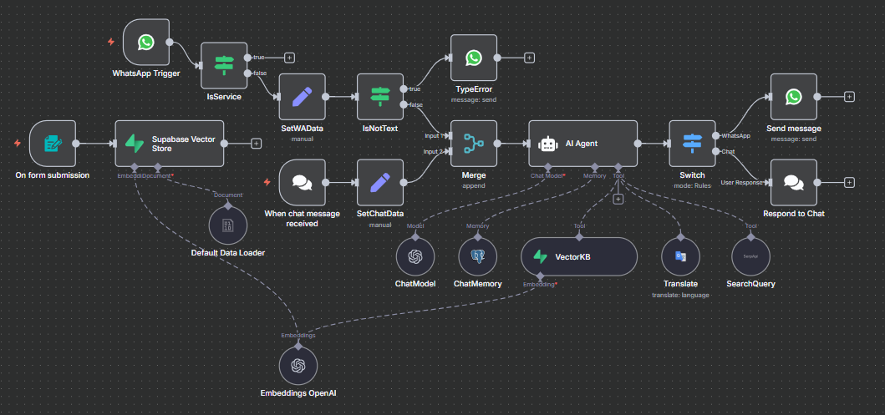

**Breakdown:**

|  |  |
| --- | --- |
| **Section** | **Description** |
| Input Triggers | WhatsApp Trigger via Meta API or Web Chat |
| Pre-Processing | Filter non-user messages (IsService), check for unsupported types (IsNotText) |
| Data Routing | Set chat or WhatsApp data context using SetWAData / SetChatData |
| Merge Input | Unified path to AI Agent |
| AI Agent Node | Connected to ChatModel, ChatMemory, VectorKB, and Translate tools |
| Response Routing | Switch node checks source (WhatsApp or Chat) to send back response |

# 4. AI Agent System Prompt Summary

The AI agent was configured with the following constraints and behavioral logic (adjusted to match **actual implementation**):

## a. Goals Implemented

* Educate users on **preventive healthcare**
* Help identify **early symptoms of common diseases**
* Support **multilingual, culturally aware responses**

## b. Language Handling

* Supports English, Hindi, Marathi, Odia, Telugu, Tamil, Bengali, and others
* Uses Google Translate API in n8n workflow
* Greeting override: greetings are always responded to in **English**
* Translations are used only when needed for downstream tools (like vector search)
* Maintains original input for consistency in reply language

## c. Tool Usage Logic

* **VectorKB**: Always queried first using English-translated text (if needed)
* **Translate**: Only used when message isn't in English
* **InternalKnowledgeBase**: Used if no relevant vectors are returned
* **SearchQuery**: Used to query Google Search Engine

## d. Ethics & Safety

* No diagnoses or treatments suggested
* Asks for clarification when unsure
* Reminds users to consult qualified doctors for medical concerns
* No personal/sensitive data collected unnecessarily

# 5. 3-Day Development Plan & Execution

|  |  |
| --- | --- |
| **Day** | **Tasks** |
| **Day 1** | Explored disease content on 1mg.com |
| Scraped sample (Bipolar Disorder) page |
| Built initial n8n flow for uploading text into Supabase |
| **Day 2** | Crawled full 1mg disease list |
| Cleaned & saved each disease to .txt |
| Set up Supabase DB with pg_vector support |
| Embedded text using OpenAI and uploaded |
| **Day 3** | Finalized RAG workflow with AI Agent in n8n |
| Added translation step |
| Configured WhatsApp via Meta App |
| Added ChatMemory and error handling |
| Routed outputs via Switch (Chat or WhatsApp) |

# 6. Tech Stack

|  |  |
| --- | --- |
| **Component** | **Tool / Tech** |
| Workflow Automation | n8n |
| LLM | OpenAI Chat Model (GPT-4.1-mini) |
| Embedding Model | OpenAI Embeddings |
| Vector Store | Supabase (pg_vector) |
| Memory | Postgres ChatMemory (via SupaBase) |
| Language Translation | Google Translate (via n8n) |
| Search Tool | SerperAPI (via n8n) |
| Input Channels | WhatsApp, n8n Chat Node |
| Scraping Tools | Python + BeautifulSoup |

# 7. Future Scope

|  |  |
| --- | --- |
| **Feature** | **Description** |
| Vaccination Schedules | Integrate with MoHFW API for schedule lookup |
| Outbreak Alerts | Use public data sources for real-time notifications |
| Government Scheme Checker | Lookup based on Aadhaar, ration card, etc. |
| Location-Specific Intelligence | Use device location or manual input |
| Analytics Dashboard | User queries, region heatmaps, FAQ tracking |
| Voice / IVR Bot | For accessibility in low-literacy regions |
| SMS Channel | Support feature phone users |

# 8. Summary

Successfully built a **multilingual, document-aware health assistant**, powered by:

* Document scraping and vector embedding
* Retrieval-augmented generation (RAG)
* Contextual memory
* Multi-platform delivery (Chat + WhatsApp)
* Dynamic translation with fallback handling

Delivered as a cloud-scalable solution targeting health tech pilots and awareness tools.

# 9. Demo

Here is the link to the demo: <https://www.youtube.com/watch?v=J2RtYsqWYdw>